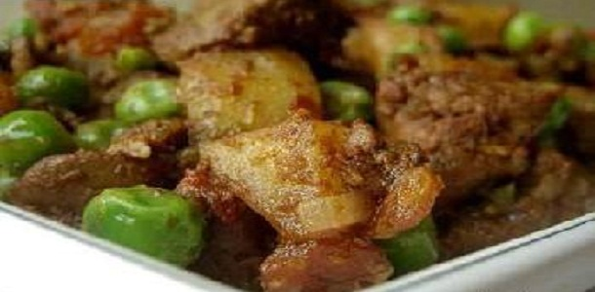

**Chicken Liver Masala**

Ingredients:

* Chicken liver – 1 lb
* Oil – 4 tbsp
* 1 Onion(chopped)
* 5 Cinnamom (broken into pieces)
* 2 Potatoes (peeled and diced)
* Salt for taste
* Warm water – 90 ml
* 4 pieces of Garlic(crushed)
* 4 Tomatoes diced
* Frozen green peas – 100 gm
* 3 Green chillies
* 1/2 tsp Garam masala powder

**For the paste:**

* 2 table spoons Water
* 2 tsp Coriander powder
* 1 tea spoon Cumin seed(Jeerakam) powder
* 1 teaspoon Turmeric powder
* 1/2 tea spoon Chilly powder

Method:

1. Clean the liver, remove all the skin and cut roughly into 1.5 cm pieces.
2. Heat 2 tbsp oil over medium heat.
3. Fry the onions and cinnamon, until the onions are soft.
4. Add the potatoes, salt and stir-fry the potatoes for about 2 minutes.
5. Add some water, cover the pan and simmer until the potatoes are tender.
6. Heat the remaining oil over medium heat in a heavy bottomed wide pan.(A non-stick or cast iron pan is ideal as the liver needs to be stir fried over high heat.)
7. Add the garlic and stir-fry for 30 sec.
8. Add the spice paste, lower the heat and stir fry for about 2 minutes.
9. Add half of the tomatoes, along with some of the juice, stir and cook for further 2-3 minutes, breaking the tomatoes with the spoon.
10. When the mixture is fairly dry, add the liver and adjust heat to medium high.
11. Stir-fry the liver for 3-4 minutes.
12. Add the remaining tomatoes and the juice, stir-fry for 5-6 minutes.
13. Cover the pan and simmer for about 8 minutes.
14. Add the potatoes, green peas, green chillies and the remaining salt and cook for a minute or two.
15. Adjust heat to medium and cook uncovered for further 5 minutes.
16. Stir in the garam masala powder and remove from heat.

:- Serve with plain fried rice or chapathis or rotis.